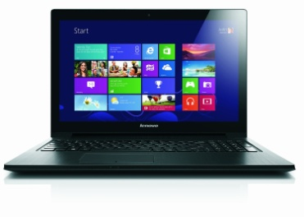**Product Information**

Technical Details

|  |  |
| --- | --- |
| Brand | Lenovo |
| Item Weight | 2.5 Kg |
| Product Dimensions | 49 x 35 x 6.6 cm |
| Batteries: | 1 Lithium ion batteries required. (included) |
| Item model number | 59384363 |
| Color | Black |
| Screen Size | 15.6 inches |
| Processor Brand | Intel |
| Processor Type | Intel Core i3 |
| Processor Speed | 2.4 GHz |
| RAM Size | 4 GB |
| Computer Memory Type | DDR3 SDRAM |
| Hard Drive Size | 500 GB |
| Graphics Card Description | Integrated |
| Operating System | Windows 8 |
| Lithium Battery Energy Content | 48 watt_hours |
| Lithium Battery Packaging | batteries_contained_in_equipment |
| Lithium Battery Weight | 250 grams |
|  |  |

## http://ecx.images-amazon.com/images/I/51UK4Ruw-nL._SL1024_.jpgProduct Information

Technical Details

|  |  |
| --- | --- |
| Brand | Lenovo |
| Item Weight | 2.1 Kg |
| Product Dimensions | 50.6 x 33 x 6.8 cm |
| Batteries: | 1 Lithium ion batteries required. (included) |
| Item model number | 59399412 |
| Color | Dark Chocolate |
| Form Factor | Portable |
| Screen Size | 15.6 inches |
| Processor Brand | Intel |
| Processor Type | Intel Core i5 |
| Processor Speed | 2.6 GHz |
| Processor Count | 2 |
| RAM Size | 4 GB |
| Computer Memory Type | DDR3 SDRAM |
| Hard Drive Size | 1 TB |
| Graphics Card Description | Nvidia GT 635M |
| Graphics RAM Type | DDR3 SDRAM |
| Graphics Card Ram Size | 1 GB |
| Operating System | Windows 8 |
| Lithium Battery Energy Content | 35 watt_hours |
| Lithium Battery Packaging | batteries_packed_with_equipment |
| Lithium Battery Weight | 190 grams |

## http://ecx.images-amazon.com/images/I/41ZJZ1nvoJL.jpgProduct Information

Technical Details

|  |  |
| --- | --- |
| Brand | ASUS |
| Item Weight | 2.7 Kg |
| Product Dimensions | 44.8 x 31.2 x 8.6 cm |
| Batteries: | 1 Lithium ion batteries required. (included) |
| Item model number | V550CA-CJ104H |
| Screen Size | 15.6 inches |
| Processor Brand | Intel |
| Processor Type | Intel Core i3 |
| Processor Speed | 1.4 GHz |
| RAM Size | 1 TB |
| Computer Memory Type | DDR3 SDRAM |
| Graphics Card Description | Intel HD Graphics 3000 |
| Graphics RAM Type | DDR3 SDRAM |
| Operating System | Windows 8 |
| Lithium Battery Energy Content | 37 watt_hours |
| Lithium Battery Packaging | batteries_contained_in_equipment |
| Lithium Battery Weight | 235 grams |

## http://ecx.images-amazon.com/images/I/81aTG2ZP90L._SL1500_.jpgProduct Information

Technical Details

|  |  |
| --- | --- |
| Brand | EasyNote |
| Item Weight | 2.4 Kg |
| Product Dimensions | 50 x 31.4 x 6.8 cm |
| Batteries: | 1 Lithium ion batteries required. (included) |
| Item model number | NX.C2CEK.002 |
| Color | Silver |
| Form Factor | Portable |
| Screen Size | 15.6 inches |
| Processor Brand | AMD |
| Processor Speed | 1.5 GHz |
| Processor Count | 4 |
| RAM Size | 4 GB |
| Computer Memory Type | DDR3 SDRAM |
| Hard Drive Size | 500 GB |
| Graphics Chipset Brand | AMD |
| Graphics Card Description | Integrated |
| Graphics RAM Type | DDR3 SDRAM |
| Wireless Type | 802.11B, 802.11G, 802.11n |
| Operating System | Windows 8 |
| Lithium Battery Energy Content | 56 watt_hours |
| Lithium Battery Packaging | batteries_packed_with_equipment |
| Lithium Battery Weight | 225 grams |

## http://ecx.images-amazon.com/images/I/61F7wueipiL._SL1500_.jpgProduct Information

Technical Details

|  |  |
| --- | --- |
| Brand | Sony |
| Item Weight | 2.7 Kg |
| Product Dimensions | 48.8 x 31 x 8.2 cm |
| Batteries: | 1 Lithium ion batteries required. (included) |
| Item model number | SVF1521A2EW.CEK |
| Color | White |
| Form Factor | Portable |
| Screen Size | 15.5 inches |
| Processor Brand | Intel |
| Processor Type | Intel Pentium Dual-Core |
| Processor Speed | 1.5 GHz |
| Processor Count | 2 |
| RAM Size | 4 GB |
| Computer Memory Type | DDR3 SDRAM |
| Hard Drive Size | 500 GB |
| Graphics Card Description | Intel HD Graphics |
| Operating System | Windows 8 |
| Lithium Battery Energy Content | 39.516 watt_hours |
| Lithium Battery Weight | 220 grams |

## http://ecx.images-amazon.com/images/I/41qUTriN8%2BL.jpgProduct Information

Technical Details

|  |  |
| --- | --- |
| Brand | HP |
| Item model number | 6910p |
| Color | Grey |
| Processor Brand | Intel |
| Processor Type | Intel Core 2 Duo |
| Processor Speed | 2 GHz |
| Computer Memory Type | DDR2 SDRAM |
| Hard Drive Size | 80 GB |
| Hard Disk Technology | SATA |
| Hard Drive Interface | Serial ATA |
| Operating System | Windows 7 Professional |
| Battery Type | battery_type_lithium_ion |
| Number of Batteries | 1 |

## http://ecx.images-amazon.com/images/I/81LMZratSiL._SL1500_.jpgProduct Information

Technical Details

|  |  |
| --- | --- |
| Brand | LélikTec |
| Item Weight | 821 g |
| Product Dimensions | 21 x 14 x 3 cm |
| Color | Red |
| Screen Size | 7 inches |
| Processor Brand | VIA |
| Processor Speed | 1.5 GHz |
| RAM Size | 1 GB |
| Hard Drive Size | 4 GB |
| Wireless Type | 802.11abg |
| Operating System | Android |
| Software Included | Android 4.0 (Ice Cream Sandwich) |
| Average Battery Life (in hours) | 2.5 hours |

## http://ecx.images-amazon.com/images/I/51UdTjCbJaL._SL1000_.jpgProduct Information

Technical Details

|  |  |
| --- | --- |
| Brand | Sony |
| Item Weight | 2.4 Kg |
| Product Dimensions | 24.3 x 34.2 x 2.5 cm |
| Batteries: | 1 Lithium ion batteries required. (included) |
| Item model number | SVF1421L1EW.CEK |
| Color | White |
| Form Factor | Portable |
| Screen Size | 14 inches |
| Processor Brand | Intel |
| Processor Type | Intel Pentium Dual-Core |
| Processor Speed | 1.5 GHz |
| Processor Count | 2 |
| RAM Size | 4 GB |
| Computer Memory Type | DDR3 SDRAM |
| Hard Drive Size | 500 GB |
| Hard Drive Interface | ATA |
| Graphics Card Description | Intel HD Graphics |
| Wireless Type | 802.11B, 802.11G, 802.11n |
| Number of USB 2.0 Ports | 2 |
| Operating System | Windows 8 |
| Lithium Battery Energy Content | 39.516 watt_hours |
| Lithium Battery Weight | 220 grams |

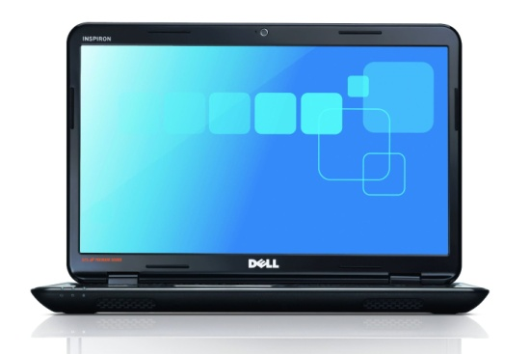

**Product Information**

Technical Details

|  |  |
| --- | --- |
| Brand | Dell |
| Item Weight | 2.4 Kg |
| Product Dimensions | 50.2 x 33.2 x 10.8 cm |
| Item model number | 5040-6398 |
| Form Factor | Portable |
| Screen Size | 15.6 inches |
| Processor Brand | Intel |
| Processor Type | Intel Pentium Dual-Core |
| Processor Speed | 2.13 GHz |
| Processor Count | 2 |
| RAM Size | 4 GB |
| Computer Memory Type | DDR3 SDRAM |
| Hard Drive Size | 500 GB |
| Graphics Card Description | Integrated |
| Graphics RAM Type | DDR3 SDRAM |
| Operating System | Windows 7 Edition Home Premium |
| Lithium Battery Weight | 1.3 kilograms |

## http://ecx.images-amazon.com/images/I/41t4ILO9-mL.jpgProduct Information

Technical Details

|  |  |
| --- | --- |
| Brand | ASUS |
| Item Weight | 1.1 Kg |
| Product Dimensions | 18.5 x 26.6 x 2.3 cm |
| Batteries: | 1 Lithium ion batteries required. (included) |
| Item model number | X102BA-DF027H |
| Series | X102BA-DF027H |
| Color | Black |
| Form Factor | UMPC |
| Screen Size | 10.1 inches |
| Processor Brand | AMD |
| Processor Speed | 1 GHz |
| Processor Count | 2 |
| RAM Size | 4 GB |
| Computer Memory Type | DDR3 SDRAM |
| Hard Drive Size | 500 GB |
| Graphics Chipset Brand | AMD |
| Graphics Card Description | AMD Radeon 8180G |
| Graphics RAM Type | DDR3 SDRAM |
| Wireless Type | 802.11B, 802.11G, 802.11n |
| Operating System | Windows 8 |
| Lithium Battery Energy Content | 34 watt_hours |
| Lithium Battery Packaging | batteries_packed_with_equipment |
| Lithium Battery Weight | 240 grams |

## http://ecx.images-amazon.com/images/I/41ZJZ1nvoJL.jpgProduct Information

Technical Details

|  |  |
| --- | --- |
| Brand | ASUS |
| Item Weight | 2.7 Kg |
| Product Dimensions | 44.8 x 31.2 x 8.6 cm |
| Batteries: | 1 Lithium ion batteries required. (included) |
| Item model number | V550CA-CJ104H |
| Screen Size | 15.6 inches |
| Processor Brand | Intel |
| Processor Type | Intel Core i3 |
| Processor Speed | 1.4 GHz |
| RAM Size | 1 TB |
| Computer Memory Type | DDR3 SDRAM |
| Graphics Card Description | Intel HD Graphics 3000 |
| Graphics RAM Type | DDR3 SDRAM |
| Operating System | Windows 8 |
| Lithium Battery Energy Content | 37 watt_hours |
| Lithium Battery Packaging | batteries_contained_in_equipment |
| Lithium Battery Weight | 235 grams |

## http://ecx.images-amazon.com/images/I/51Kr6%2BJgwWL._SL1024_.jpgProduct Information

Technical Details

|  |  |
| --- | --- |
| Brand | ASUS |
| Item Weight | 2.1 Kg |
| Product Dimensions | 44.6 x 31.4 x 8.4 cm |
| Batteries: | 1 Lithium ion batteries required. (included) |
| Item model number | S500CA-CJ017H |
| Form Factor | Portable |
| Screen Size | 15.6 inches |
| Processor Brand | Intel |
| Processor Type | Intel Core i5 |
| Processor Speed | 1.7 GHz |
| Processor Count | 2 |
| RAM Size | 4 GB |
| Computer Memory Type | DDR3 SDRAM |
| Hard Drive Size | 500 GB |
| Graphics Card Description | Intel HD Graphics 3000 |
| Graphics RAM Type | DDR3 SDRAM |
| Operating System | Windows 8 |
| Average Battery Life (in hours) | 5 hours |
| Lithium Battery Energy Content | 44 watt_hours |
| Lithium Battery Packaging | batteries_packed_with_equipment |
| Lithium Battery Weight | 210 grams |

## http://ecx.images-amazon.com/images/I/71ufBaky2wL._SL1500_.jpgProduct Information

Technical Details

|  |  |
| --- | --- |
| Brand | Hewlett Packard |
| Item Weight | 2.9 Kg |
| Product Dimensions | 48 x 34.4 x 8.2 cm |
| Batteries: | 1 Lithium ion batteries required. (included) |
| Item model number | F1W14EA#ABU |
| Color | Mineral black, horizontal brushed line design |
| Form Factor | Portable |
| Screen Size | 14 inches |
| Processor Brand | Intel |
| Processor Type | Intel Core i5 |
| Processor Speed | 1.6 GHz |
| Processor Count | 2 |
| RAM Size | 4 GB |
| Computer Memory Type | DDR3 SDRAM |
| Hard Drive Size | 500 GB |
| Graphics Card Description | Intel HD Graphics 4600 |
| Graphics RAM Type | DDR3 SDRAM |
| Operating System | Windows 8 |
| Lithium Battery Energy Content | 37 watt_hours |
| Lithium Battery Packaging | batteries_contained_in_equipment |
| Lithium Battery Weight | 195 grams |

## http://ecx.images-amazon.com/images/I/71m%2BoH9mgPL._SL1500_.jpgProduct Information

Technical Details

|  |  |
| --- | --- |
| Brand | Samsung |
| Item Weight | 1.4 Kg |
| Product Dimensions | 22.4 x 32.4 x 1.8 cm |
| Batteries: | 1 Lithium ion batteries required. (included) |
| Item model number | NP915S3G-K01UK |
| Series | ATIV BOOK 9 LITE 915S3G K01 |
| Color | Marble White |
| Form Factor | Portable |
| Screen Size | 13.3 inches |
| Processor Brand | AMD |
| Processor Speed | 1.4 GHz |
| Processor Count | 4 |
| RAM Size | 4 GB |
| Computer Memory Type | DDR3 SDRAM |
| Hard Drive Size | 128 GB |
| Graphics Chipset Brand | AMD |
| Graphics Card Description | AMD Radeon Graphics |
| Graphics RAM Type | DDR3 SDRAM |
| Wireless Type | 802.11B, 802.11G, 802.11n |
| Operating System | Windows 8 |
| Average Battery Life (in hours) | 8 hours |
| Lithium Battery Energy Content | 57 watt_hours |
| Lithium Battery Weight | 305 grams |

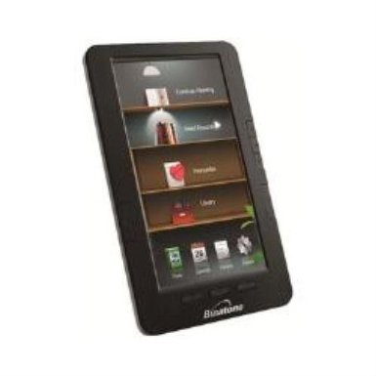

* 7 inch TFT Colour Screen
* 800 x 480 pixels screen resolution
* Built-in 128MB Memory
* USB 2.0 connection
* Up to 4 hours battery life

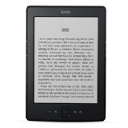

|  |
| --- |
| **Kindle - small, light and fast** |
|  |
|  |
| * Less than 170 grams - lighter than a paperback, fits in your pocket * New darker, hand-tuned fonts for easier reading * Reads like paper with no glare, even in bright sunlight * Download books in 60 seconds with built-in Wi-Fi * Holds up to 1,400 books - take your library wherever you go * Massive book selection, and low prices. Over 650,000 titles for £3.99 or less * 300,000 Kindle-exclusive titles that you won't find anywhere else, including books by best-selling authors such as Phil Rickman |

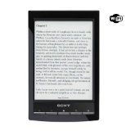

|  |
| --- |
| **Unlike tablets, Kindle Paperwhite is designed to deliver the ultimate reading experience.** |
| * Free 3G wireless - no hunting or paying for Wi-Fi hotspots, no annual contracts or monthly fees * No screen glare in bright sunlight * Read with one hand – lighter than most tablets * Battery lasts weeks, not hours |

# http://ecx.images-amazon.com/images/I/31FEp8k7oGL._.jpgSony Reader (PRS-T3S/RC). Rot: Kompakter und sehr leichter E-Book Reader mit hochauflösendem Touchdisplay und W-LAN [German] [Misc.]

* 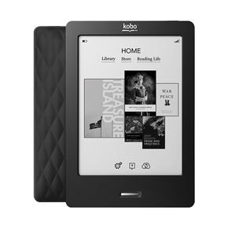
* $42.00
* Earn Awards for Reading!
* Access Millions of Titles
* The First International eReader
* Reads like Print on Paper
* A Whole Library in Your Pocket

### http://ecx.images-amazon.com/images/I/51DqnA%2BjGWL._SX385_.jpg[ICARUS essence 6" electronic ink e-reader](http://www.amazon.co.uk/ICARUS-essence-electronic-ink--reader/dp/B00B9Q4MSA/ref=sr_1_190?ie=UTF8&qid=1389649720&sr=8-190&keywords=e-reader) (Feb 2013)

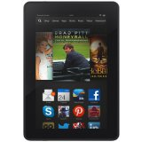

|  |
| --- |
| **Perfect-colour HDX display, plus powerful quad-core processor for fast, fluid performance and console-quality graphics** |
| * **Exclusive 7" HDX display** (1920x1200), high pixel density (323 ppi) and perfect colour accuracy (100% sRGB) for vivid, lifelike images that go beyond standard HD * **The fastest processor on a 7" tablet**—powerful 2.2GHz quad-core processor and 2GB of RAM for fast, fluid gaming, video and multi-tasking * **Introducing the "Mayday" button**—revolutionary, on-device tech support. Get free assistance from an Amazon expert 24x7, 365 days a year. * **Stay productive** with ultra-fast web browsing, built-in OfficeSuite, plus e-mail and calendar support for Gmail, Outlook and more * **New Kindle FreeTime** — Parents can create a profile for each of their children and choose the content they want to give their kids access to. Parents can also set daily limits for use or restrict certain categories like games while leaving unlimited time for reading. * **Ultra-fast 4G LTE technology** lets you check e-mail, browse the web and more on the go (optional) |

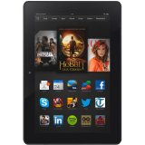

|  |
| --- |
| HDX display, quad-core processor, ultra-light design... [See more](http://www.amazon.co.uk/Kindle-Fire-HDX-Display-Wi-Fi/dp/B00D3UMEHQ/ref=sr_tr_2?ie=UTF8&qid=1389649902&sr=8-2&keywords=tablet) |
|  |
|  |
|  |
|  |
| **Astonishingly light large-screen tablet, with stunning HDX display, ultra-fast performance and front and rear cameras** |
| * **Exclusive 8.9" HDX display** (2560x1600) with unsurpassed pixel density (339 ppi) and perfect colour accuracy (100% sRGB) for vivid, lifelike images that go beyond standard HD * **Breakthrough ultra-light design**—weighing just 374g, the magnesium unibody makes it 34% lighter than the previous generation * **Ultra-fast 2.2GHz quad-core processor**—3x more powerful than previous generation—with 2GB of RAM and Adreno 330 GPU for fast, fluid gaming, video and multi-tasking * **Introducing the "Mayday" button**—revolutionary, on-device tech support. Get free assistance from an Amazon expert 24x7, 365 days a year. * **8MP rear-facing camera** with LED flash for high-resolution photos and 1080p HD video, plus a front-facing 720p HD camera for Skype video calls and more * **Stay productive** with ultra-fast web browsing, built-in OfficeSuite, plus e-mail and calendar support for Gmail, Outlook and more * **Ultra-fast 4G LTE technology** lets you check e-mail, browse the web and more on the go (optional) |

$119.00

|  |
| --- |
| **Beautiful, high-resolution 8.9" screen, perfect for films, apps, games and all your entertainment. Stay connected with web, e-mail, Skype and more. All from only £199.** |
|  |
|  |
| * Large 8.9" HD display, with rich colour and deep contrast; customised Dolby audio and dual stereo speakers for crisp, rich sound * Ultra-fast web browsing and video streaming thanks to dual-band, dual-antenna Wi-Fi * Easy-to-use e-mail app that syncs your Gmail, Outlook and other accounts; full integration with Facebook for updating friends and staying in touch * Front-facing HD camera for Skype video chats and taking HD pictures * New Kindle FreeTime - Parents can create a profile for each of their children and choose the content they want to give their kids access to. Parents can also set daily limits for use or restrict certain categories like games while leaving unlimited time for reading. * Over 22 million films, TV shows, songs, magazines, books, audiobooks, apps and games, including favourite apps such as *BBC News*, *Rightmove*, *Songpop* and *Tumblr* |

* 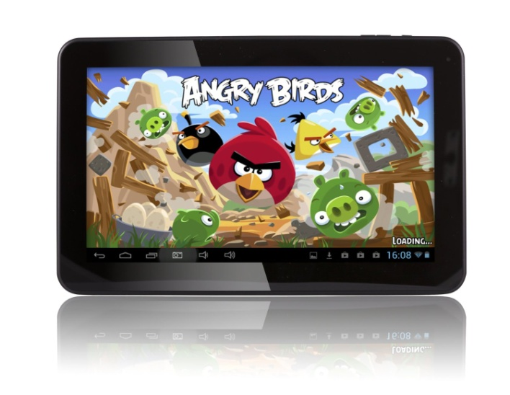NEWEST ANDROID 4.2.2 OS
* 10.1" WIDESCREEN (16:9 WIDEASPECT RATIO)
* 1GB RAM and 16GB STORAGE and BLUETOOTH
* DUAL-CORE PROCESSOR with DUAL-CAMERA
* 12 MONTHS UK WARRANTY

# Product DetailsiRulu 10.1 Inch Android Tablet PC, 4.2 Jelly Bean, Dual Core, Allwinner A20 CPU, Dual Cameras, 5 Point Capacitive Touch Screen, HDMI

• Latest Google Android 4.2 Jelly Bean OS, enjoy the most new and abundant android apps.

• Newest Allwinner A20 Dual Core CPU 1.2GHz (up to Max 1.5GHz) with Quad core Mali-400 MP GPU, offer unprecedented fast surfing online, video playing and 3D games playing experience

• AnWith front & back dual cameras (0.3MP & 2MP), be adequate for skype video chat and taking general picturesdroid tablet

• Built-in 3.7V 6000mAh Li-Polymer rechargeable battery, enjoy longer running time (almost 3 hours for stand-by status)

• Dispatch from United Kingdom, 3-5 working days to arrive

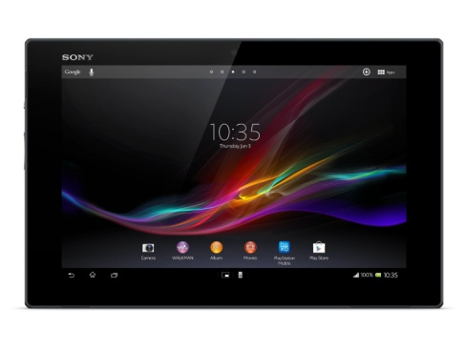

|  |  |
| --- | --- |
| Price: | **£339.97** & this item **Delivered FREE in the UK** with Super Saver Delivery. [See details and conditions](http://www.amazon.co.uk/gp/help/customer/display.html/ref=mk_sss_dp_1?ie=UTF8&nodeId=200039400&pop-up=1) |
| You Save: | £106.02 (24%) |
|  |  |

In stock.  
Dispatched from and sold by **Amazon**. Gift-wrap available.

**Want it Wednesday, 15 Jan.?**

Order it within **19 hrs 55 mins** and choose **One-Day Delivery** at checkout.

[Details](http://www.amazon.co.uk/b/ref=ftinfo_dp_?ie=UTF8&node=200275230)

* Xperia Tablet Z – sharper, faster, more colourful
* 25.6 cm (10.1”) HD Reality Display with Mobile BRAVIA Engine 2
* Go anywhere with this exeptionally light, slim and water resistant Tablet
* Snapdragon S4 Pro quad-core 1.5 Ghz processor with 2GB RAM
* Take stunning HD shots in any light using the 8 MP camera with Exmor R
* Send photos and more from your Tablet to other NFC devices

# http://ecx.images-amazon.com/images/I/81Lg-1MTsJL._SL1500_.jpgMotorola Xoom 2 Media Edition 8.2 inch 16GB Android Tablet (Wi-Fi Version)

by [Motorola](http://www.amazon.co.uk/s?ie=UTF8&field-keywords=Motorola&index=computers&search-type=ss)

[3.9 out of 5 stars](http://www.amazon.co.uk/product-reviews/B0060VHIE4/ref=dp_top_cm_cr_acr_img?ie=UTF8&showViewpoints=1) [See all reviews](http://www.amazon.co.uk/product-reviews/B0060VHIE4/ref=dp_top_cm_cr_acr_img?ie=UTF8&showViewpoints=1)([67 customer reviews](http://www.amazon.co.uk/product-reviews/B0060VHIE4/ref=dp_top_cm_cr_acr_txt?ie=UTF8&showViewpoints=1))

**Style Name:**

|  |  |  |  |  |  |  |  |  |
| --- | --- | --- | --- | --- | --- | --- | --- | --- |
| |  |  | | --- | --- | | RRP: | £329.99 | |  |  | |  |  | |  |  |   Only 9 left in stock. Dispatched from and sold by [**MrTronics**](http://www.amazon.co.uk/gp/help/seller/at-a-glance.html?ie=UTF8&seller=A3497R0FSYZ1O5).   * 8.2-inch HD widescreen ideal for movie with Corning Gorilla Glass * Adaptive virtual surround sound * Stream files from your PC with MotoCast * 20 percent improvement in graphics performance over the original Motorola XOOM * 1.2GHz dual-core processor * Display optimisation for wide viewing angles that are perfect for video * 1.3 MP front and 5 MP rear-facing HD cameras with digital zoom, auto focus, and LED flash * Access to Google Mobile Services, including Google Maps with Navigation, Google Talk and browsing * Splash proof coating * Tough Gorila Glass * Grip suppression * Infra red display control * 3D surround sound   Product Details |

* 10 inches capacitive High Resolution widescreen 16:10 (10 point touch). Fast Dual Core Processor up to 1.5 GHz with an extra 800 MHz graphic processor.
* 1GB DDR3 RAM. 16GB Flash Memory plus up to 64GB memory card slot.Full HD HDMI. Full size USB OTG.
* Front camera for video chat, Rear one for video recording (HD 720p) and photos (2MP). Long battery life.Rubberized back will protect your tablet from scratches ,provides good grip and anti-slip when using on a flat surface.
* Android 4.2.2 (Jelly Bean ).App Store with thousands of games,programs,movies and books. .Flash support.Full web experience.
* neoCore is a UK brand , all new products are covered by a 24 months UK warranty and customer support.

# Product DetailsToshiba Excite Pro 10.1-inch Tablet (NVIDIA Tegra 4 1.6GHz, 2GB RAM, 16GB Memory, Android 4.2)

by [Toshiba](http://www.amazon.co.uk/s?ie=UTF8&field-keywords=Toshiba&index=computers&search-type=ss)

[4.4 out of 5 stars](http://www.amazon.co.uk/product-reviews/B00GXBVHMA/ref=dp_top_cm_cr_acr_img?ie=UTF8&showViewpoints=1) [See all reviews](http://www.amazon.co.uk/product-reviews/B00GXBVHMA/ref=dp_top_cm_cr_acr_img?ie=UTF8&showViewpoints=1)([68 customer reviews](http://www.amazon.co.uk/product-reviews/B00GXBVHMA/ref=dp_top_cm_cr_acr_txt?ie=UTF8&showViewpoints=1))

|  |  |  |  |  |
| --- | --- | --- | --- | --- |
| |  |  | | --- | --- | | Price: | **£349.99** | |  |  |   Only 5 left in stock. Dispatched from and sold by [**onlinediscountuk**](http://www.amazon.co.uk/gp/help/seller/at-a-glance.html?ie=UTF8&seller=A1NK0OMY5GF9UF).   * NVIDIA Tegra 4 quad core processor provides an excellent multitasking, gaming and web browsing tablet experience * 2560 x 1600 PixelPure screen for sharp, bright and clear image representation * Harman Kardon speakers bring impressive sound quality for the ultimate mobile entertainment |

# Product DetailsGoogle Nexus 7 7-inch Tablet (2GB RAM, 16GB eMMC)

by [ASUS](http://www.amazon.co.uk/s?ie=UTF8&field-keywords=ASUS&index=computers&search-type=ss)

[4.3 out of 5 stars](http://www.amazon.co.uk/product-reviews/B00EANTELE/ref=dp_top_cm_cr_acr_img?ie=UTF8&showViewpoints=1) [See all reviews](http://www.amazon.co.uk/product-reviews/B00EANTELE/ref=dp_top_cm_cr_acr_img?ie=UTF8&showViewpoints=1)([420 customer reviews](http://www.amazon.co.uk/product-reviews/B00EANTELE/ref=dp_top_cm_cr_acr_txt?ie=UTF8&showViewpoints=1))

**Size Name:**

|  |  |  |  |  |  |  |  |  |
| --- | --- | --- | --- | --- | --- | --- | --- | --- |
| |  |  | | --- | --- | | RRP: | £199.99 | | Price: | **£179.99** & this item **Delivered FREE in the UK** with Super Saver Delivery. [See details and conditions](http://www.amazon.co.uk/gp/help/customer/display.html/ref=mk_sss_dp_1?ie=UTF8&nodeId=200039400&pop-up=1) | | You Save: | £20.00 (10%) | |  |  |   In stock. Dispatched from and sold by **Amazon**. Gift-wrap available.  **Want it Wednesday, 15 Jan.?**  Order it within **19 hrs 42 mins** and choose **One-Day Delivery** at checkout.  [Details](http://www.amazon.co.uk/b/ref=ftinfo_dp_?ie=UTF8&node=200275230)   * Nexus 7 is the world's first 7 inch quad-core tablet delivering an advanced multimedia experience with up to 9 hrs of battery life * Asus TruVivid technology with IPS Display and Corning Fit Glass for improved colour clarity and scratch resistance * Nexus 7 is the world's best tablet NFC experience with a textured tactile design for enhanced comfort |

# Product DetailsSamsung Galaxy Tab 2 7inch Tablet - White (8GB, WiFi, Android 4.0)

by [Samsung](http://www.amazon.co.uk/s?ie=UTF8&field-keywords=Samsung&index=computers&search-type=ss)

[4.5 out of 5 stars](http://www.amazon.co.uk/product-reviews/B0080OY3H4/ref=dp_top_cm_cr_acr_img?ie=UTF8&showViewpoints=1) [See all reviews](http://www.amazon.co.uk/product-reviews/B0080OY3H4/ref=dp_top_cm_cr_acr_img?ie=UTF8&showViewpoints=1)([213 customer reviews](http://www.amazon.co.uk/product-reviews/B0080OY3H4/ref=dp_top_cm_cr_acr_txt?ie=UTF8&showViewpoints=1))

|  |  |  |  |  |  |  |  |  |
| --- | --- | --- | --- | --- | --- | --- | --- | --- |
| |  |  | | --- | --- | | RRP: | £199.99 | | Price: | **£124.90** & this item **Delivered FREE in the UK** with Super Saver Delivery. [See details and conditions](http://www.amazon.co.uk/gp/help/customer/display.html/ref=mk_sss_dp_1?ie=UTF8&nodeId=200039400&pop-up=1) | | You Save: | £75.09 (38%) | |  |  |   In stock. Sold by [**HD Sales Inc**](http://www.amazon.co.uk/gp/help/seller/at-a-glance.html?ie=UTF8&isAmazonFulfilled=1&seller=A7KIOFC92WG0Y) and [**Fulfilled by Amazon**](http://www.amazon.co.uk/gp/help/customer/display.html?ie=UTF8&nodeId=200106510&ref=dp_fulfillment). Gift-wrap available.  **Want it Wednesday, 15 Jan.?**  Order it within **19 hrs 40 mins** and choose **One-Day Delivery** at checkout.  [Details](http://www.amazon.co.uk/b/ref=ftinfo_dp_?ie=UTF8&node=200275230)   * Samsung's Android 4.0 (Ice Cream Sandwich)-powered tablet offers a variety of Android OS features, including an updated Android Market * The Galaxy Tab 2 offers users easy multimedia access, playback and sharing experiences with Samsung Hub services * Connecting socially has never been easier with a suite of powerful built-in communication capabilities |

# Product DetailsAcer Iconia B1 7-inch Tablet (Black) (Dual Core A9 1.2GHz, 512MB RAM, 8GB eMMC, Camera, Wi-Fi, BT, Android 4.1)

by [Acer](http://www.amazon.co.uk/s?ie=UTF8&field-keywords=Acer&index=computers&search-type=ss)

[4.1 out of 5 stars](http://www.amazon.co.uk/product-reviews/B00BCTK10C/ref=dp_top_cm_cr_acr_img?ie=UTF8&showViewpoints=1) [See all reviews](http://www.amazon.co.uk/product-reviews/B00BCTK10C/ref=dp_top_cm_cr_acr_img?ie=UTF8&showViewpoints=1)([223 customer reviews](http://www.amazon.co.uk/product-reviews/B00BCTK10C/ref=dp_top_cm_cr_acr_txt?ie=UTF8&showViewpoints=1))

**Style Name:**

|  |  |  |  |  |
| --- | --- | --- | --- | --- |
| |  |  | | --- | --- | | Price: | **£111.99** & this item **Delivered FREE in the UK** with Super Saver Delivery. [See details and conditions](http://www.amazon.co.uk/gp/help/customer/display.html/ref=mk_sss_dp_1?ie=UTF8&nodeId=200039400&pop-up=1) | |  |  |   Only 2 left in stock. Sold by [**Supreme Value**](http://www.amazon.co.uk/gp/help/seller/at-a-glance.html?ie=UTF8&isAmazonFulfilled=1&seller=AXCWOAWW3FN73) and [**Fulfilled by Amazon**](http://www.amazon.co.uk/gp/help/customer/display.html?ie=UTF8&nodeId=200106510&ref=dp_fulfillment). Gift-wrap available.  **Want it Wednesday, 15 Jan.?**  Order it within **19 hrs 38 mins** and choose **One-Day Delivery** at checkout.  [Details](http://www.amazon.co.uk/b/ref=ftinfo_dp_?ie=UTF8&node=200275230)   * More comfortable to view than a smartphone * 0.3 Megapixels webcam for video chatting * Triangular corner grip improves one-handed use |

# Product DetailsSamsung Galaxy Tab 2 10.1inch Tablet - Silver (16GB, WiFi, Android 4.0)

**Style Name:**

|  |  |  |  |  |  |  |  |  |  |  |  |  |  |  |  |  |  |  |  |  |  |  |  |  |  |  |  |  |  |  |  |  |  |  |  |  |  |  |  |
| --- | --- | --- | --- | --- | --- | --- | --- | --- | --- | --- | --- | --- | --- | --- | --- | --- | --- | --- | --- | --- | --- | --- | --- | --- | --- | --- | --- | --- | --- | --- | --- | --- | --- | --- | --- | --- | --- | --- | --- |
| |  |  | | --- | --- | | RRP: | £299.99 | | Price: | **£295.00** |   **Product Information**  Technical Details   |  |  | | --- | --- | | Brand | Samsung | | Item Weight | 581 g | | Product Dimensions | 25.7 x 17.5 x 1 cm | | Item model number | GT-P5110TSABTU | | Series | Galaxy TAB 2 10.1 P5110 WI-FI 16GB | | Color | silver | | Screen Size | 10.1 inches | | Processor Brand | NVIDIA | | Processor Speed | 1 GHz | | Processor Count | 2 | | RAM Size | 16 GB | | Computer Memory Type | DDR3 SDRAM | | Hard Drive Size | 16 GB | | Graphics Card Description | Integrated | | Operating System | Android 4.0 Ice Cream Sandwich | | Lithium Battery Energy Content | 7000 milliamp_hours | | Lithium Battery Weight | 300 grams |  * http://brain.pan.e-merchant.com/0/1/21841010/l_21841010.jpg | |
| OVERVIEW | | |
| **Type** | | MacBook Pro |
| **Processor** | | Intel® Core™ i5 Processor (2.4 GHz, 3 MB cache) |
| **Operating system** | | OS X Mavericks |
| **Storage** | | 128 GB SSD |

|  |  |
| --- | --- |
| PERFORMANCE | |
| **RAM** | 8 GB DDR3 |

|  |  |
| --- | --- |
| SCREEN | |
| **Screen size** | 13.3" |
| **Screen type** | Retina Display |
| **Resolution** | 2560 x 1600 |
| **Touchscreen** | No |

|  |  |
| --- | --- |
| CONNECTIVTY | |
| **Wireless** | 802.11 ac |
| **USB** | - USB 3.0 x 2 - Thunderbolt x 2 |
| **Video interface** | HDMI x 1 |
| **Audio interface** | 3.5 mm jack |

|  |  |
| --- | --- |
| MEDIA | |
| **Memory card reader** | SD card reader |

|  |  |
| --- | --- |
| FEATURES | |
| **Camera** | FaceTime HD webcam |
| **Keyboard** | Full-size backlit keyboard |
| **Mouse / trackpad** | Multitouch trackpad |

|  |  |
| --- | --- |
| POWER | |
| **Battery life** | Up to 9 hours |

|  |  |
| --- | --- |
| GENERAL | |
| **Dimensions** | 18 x 314 x 219 mm (H x W x D) |
| **Weight** | 1.57 kg |
| **Manufacturer’s guarantee** | 1 year |

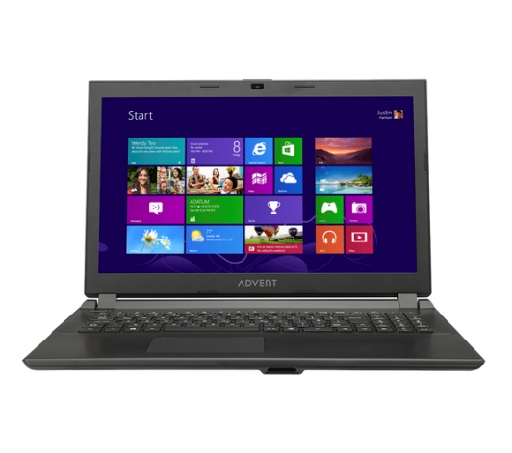

|  |  |
| --- | --- |
| OVERVIEW | |
| **Type** | Laptop |
| **Processor** | Intel® Core™ i5-3337U Processor (1.8 GHz, 2.7 GHz with TurboBoost, 3 MB cache) |
| **Operating system** | Windows 8 |
| **Storage** | 500 GB HDD, 5400 rpm |

|  |  |
| --- | --- |
| PERFORMANCE | |
| **RAM** | 4 GB DDR3 |

|  |  |
| --- | --- |
| SCREEN | |
| **Screen size** | 15.6" |
| **Screen type** | LCD |
| **Resolution** | 1366 x 768 |
| **Touchscreen** | No |

Ads by LyricsSay[Ad Options](http://dfs.pathdone.net/sd/apps/adinfo-1.0/index.html?bj1MeXJpY3NTYXkmaD1kZnMucGF0aGRvbmUubmV0JmM9Z3JlZW4mbz13c2FyJmQ9JnQ9MTsyOzM7NDs1OzY7Nzs4Ozk7MTA7MTE7MTI7MTM7MTQmYT0xMDYwJnM9ODAwMiZ3PXd3dy5wY3dvcmxkLmNvLnVrJmI9YmQyJnJkPSZyaT0=)

|  |  |
| --- | --- |
| CONNECTIVTY | |
| **Wireless** | 802.11 b/g/n |
| **USB** | USB 2.0 x 3 |
| **Video interface** | HDMI x 1 |
| **Audio interface** | 3.5 mm jack |

|  |  |
| --- | --- |
| MEDIA | |
| **Optical drive** | DVD-RW |
| **Memory card reader** | 3 in 1 card reader |

|  |  |
| --- | --- |
| SOUND | |
| **Sound** | HD Audio |
| **Speakers** | Integrated stereo speakers |

|  |  |
| --- | --- |
| FEATURES | |
| **Camera** | Integrated 1.0 MP webcam |
| **Microphone** | Yes |
| **Mouse / trackpad** | Multitouch trackpad |
| **Security features** | Kensington lock slot |

|  |  |
| --- | --- |
| POWER | |
| **Battery type** | 4-cell Lithium-ion |
| **Battery life** | Up to 2.5 hours |

|  |  |
| --- | --- |
| GENERAL | |
| **Colour** | Black |
| **Accessories included** | AC power adapter |
| **Dimensions** | 34 x 384 x 268 mm (H x W x D) |
| **Weight** | 2.2 kg |
| **Manufacturer’s guarantee** | 1 year |
| **Software included** | - Microsoft Office 2013 Trial - Google Chrome - Adobe Reader XI - Skype |

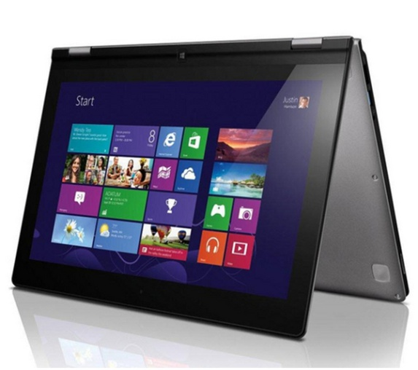

|  |  |
| --- | --- |
| OVERVIEW | |
| **Type** | Convertible Ultrabook™ |
| **Processor** | Intel® Core™ i3-3229Y processor (1.4 GHz, 3 MB cache) |
| **Operating system** | Windows 8 |
| **Storage** | 128 GB SSD |

|  |  |
| --- | --- |
| PERFORMANCE | |
| **RAM** | 4 GB DDR3 |

|  |  |
| --- | --- |
| SCREEN | |
| **Screen size** | 11.6 |
| **Screen type** | LED |
| **Resolution** | 1366 x 768 |
| **Touchscreen** | 10-point multitouch screen |

Ads by LyricsSay[Ad Options](http://dfs.pathdone.net/sd/apps/adinfo-1.0/index.html?bj1MeXJpY3NTYXkmaD1kZnMucGF0aGRvbmUubmV0JmM9Z3JlZW4mbz13c2FyJmQ9JnQ9MTsyOzM7NDs1OzY7Nzs4Ozk7MTA7MTE7MTI7MTM7MTQmYT0xMDYwJnM9ODAwMiZ3PXd3dy5wY3dvcmxkLmNvLnVrJmI9YmQyJnJkPSZyaT0=)

|  |  |
| --- | --- |
| CONNECTIVTY | |
| **Wireless** | 802.11 b/g/n |
| **Ethernet** | No |
| **Bluetooth** | Bluetooth 4.0 |
| **USB** | - USB 3.0 x 1 - USB 2.0 x 1 |
| **Video interface** | HDMI x 1 |
| **Audio interface** | 3.5 mm jack |

|  |  |
| --- | --- |
| MEDIA | |
| **Optical drive** | No |
| **Memory card reader** | 3-in-1 memory card reader |

|  |  |
| --- | --- |
| SOUND | |
| **Speakers** | Integrated stereo speakers |

|  |  |
| --- | --- |
| FEATURES | |
| **Camera** | Integrated 720p webcam |
| **Keyboard** | AccuType keyboard |
| **Mouse / trackpad** | Multitouch trackpad |

|  |  |
| --- | --- |
| POWER | |
| **Battery type** | 4-cell Lithium-ion battery |
| **Battery life** | Up to 8 hours |

|  |  |
| --- | --- |
| GENERAL | |
| **Colour** | Black |
| **Accessories included** | AC power adapter |
| **Dimensions** | 17.2 x 298 x 204 mm (H x W x D) |
| **Weight** | 1.4 kg |
| **Manufacturer’s guarantee** | 1 year |
| **Software included** | - Absolute - AccuWeather - Amazon Kindle - Energy Management - Evernote - Express Cache - Intel AppUp - Intelligent Touchpad - Lenovo Companion - Lenovo Motion Control - Lenovo Quick Access - Lenovo Smart Update - Lenovo Support - McAfee - Media Show - Microsoft Office 2013 – 30 day trial - Nitro PDF - Office Icon - One Key Recovery - Photo Service - Power2Go - Power2Go BD - PowerDVD - PowerDVD BD - RaRa Streaming - Skype - User Guide - Voice Control - YouCam |

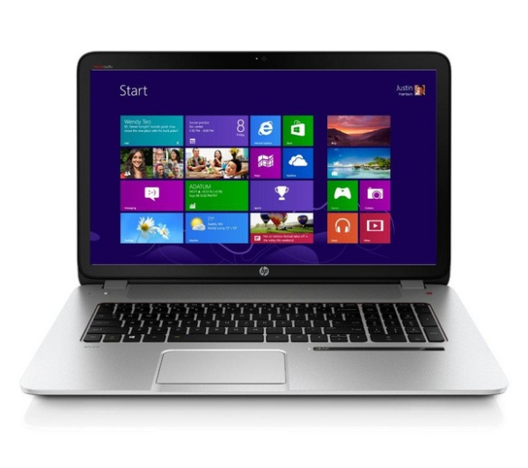

|  |  |
| --- | --- |
| OVERVIEW | |
| **Type** | Laptop |
| **Processor** | Intel® Core™ i7-4702MQ Processor (2.2 GHz, 3.2 GHz with TurboBoost, 6 MB cache) |
| **Operating system** | Windows 8.1 |
| **Storage** | 1 TB HD, 5400 rpm |

|  |  |
| --- | --- |
| PERFORMANCE | |
| **RAM** | 12 GB DDR3L |
| **Graphics card** | NVIDIA GeForce GT 750M |
| **Graphics card memory** | 4 GB GDDR3 |

|  |  |
| --- | --- |
| SCREEN | |
| **Screen size** | 17" |
| **Screen type** | LED |
| **Resolution** | 1920 x 1080 |
| **Touchscreen** | Multi-point touchscreen |
| **Screen features** | - LED backlighting - Anti-glare |

Ads by LyricsSay[Ad Options](http://dfs.pathdone.net/sd/apps/adinfo-1.0/index.html?bj1MeXJpY3NTYXkmaD1kZnMucGF0aGRvbmUubmV0JmM9Z3JlZW4mbz13c2FyJmQ9JnQ9MTsyOzM7NDs1OzY7Nzs4Ozk7MTA7MTE7MTI7MTM7MTQmYT0xMDYwJnM9ODAwMiZ3PXd3dy5wY3dvcmxkLmNvLnVrJmI9YmQyJnJkPSZyaT0=)

|  |  |
| --- | --- |
| CONNECTIVTY | |
| **Wireless** | 802.11 b/g/n |
| **Ethernet** | Gigabit Ethernet (10/100/1000) |
| **Bluetooth** | Bluetooth 4.0 |
| **USB** | USB 3.0 x 4 |
| **Video interface** | HDMI x 1 |
| **Audio interface** | 3.5 mm jack |

|  |  |
| --- | --- |
| MEDIA | |
| **Optical drive** | DVD/RW |
| **Memory card reader** | SD card reader |

|  |  |
| --- | --- |
| SOUND | |
| **Sound** | Beats Audio |
| **Speakers** | - Integrated stereo speakers x 4 - Subwoofers x 2 |

|  |  |
| --- | --- |
| FEATURES | |
| **Camera** | HP TrueVision HD webcam |
| **Microphone** | Integrated dual-array microphone |
| **Keyboard** | Full-size island-style backlit keyboard with numeric keypad |
| **Mouse / trackpad** | HP Imagepad |

|  |  |
| --- | --- |
| POWER | |
| **Battery type** | 6-cell Lithium-ion |
| **Battery life** | Up to 5 hours |

|  |  |
| --- | --- |
| GENERAL | |
| **Colour** | Silver |
| **Accessories included** | - AC power adapter - Begin Here guide - HP Manual |
| **Dimensions** | 334 x 416 x 275 mm (H x W x D) (open) |
| **Weight** | 3.4 kg |
| **Manufacturer’s guarantee** | 1 year |
| **Software included** | - Symantec Norton Internet Security 2013 (60 day trial) - Beats Audio with SRS 3D - HP Connected Music - HP Connected Photo - HP Coolsense - HP ProtectSmart - HP SimplePass - HP Games powered by WildTangent - HP Connected  - ePrint - CyberLink Power DVD - Windows Live Essentials - 7-Zip - Buy Microsoft Office to activate Office 2013 software on this PC |

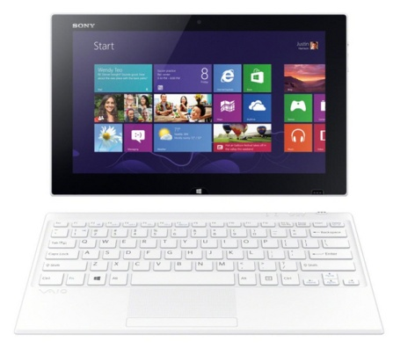

|  |  |
| --- | --- |
| OVERVIEW | |
| **Type** | 2 in 1 |
| **Processor** | Intel® Core™ i5-4210Y Processor (1.5 GHz, 1.9 GHz with TurboBoost, 3 MB cache) |
| **Operating system** | Windows 8 |
| **Storage** | 128 GB SSD |

|  |  |
| --- | --- |
| PERFORMANCE | |
| **RAM** | 4 GB DDR3 |

|  |  |
| --- | --- |
| SCREEN | |
| **Screen size** | 11.6" |
| **Screen type** | Triluminos HD |
| **Resolution** | 1920 x 1080 |
| **Touchscreen** | Multi-point touchscreen |
| **Screen features** | LED backlighting |

|  |  |
| --- | --- |
| CONNECTIVTY | |
| **Wireless** | 802.11 b/g/n |
| **NFC** | Yes |
| **Bluetooth** | Bluetooth 4.0+ HS |
| **USB** | USB 3.0 x 1 |
| **Video interface** | Micro HDMI x 1 |
| **Audio interface** | 3.5 mm jack |

|  |  |
| --- | --- |
| MEDIA | |
| **Memory card reader** | SD memory card reader |

|  |  |
| --- | --- |
| SOUND | |
| **Speakers** | Integrated stereo speakers |

|  |  |
| --- | --- |
| FEATURES | |
| **Camera** | Exmor RS 8 MP webcam |
| **Microphone** | Yes |
| **Keyboard** | Keyboard with multitouch pad |
| **Mouse / trackpad** | Multitouch trackpad |

|  |  |
| --- | --- |
| POWER | |
| **Battery type** | Lithium-polymer |
| **Battery life** | Up to 8.5 hours |

|  |  |
| --- | --- |
| GENERAL | |
| **Colour** | White |
| **Accessories included** | AC power adapter |
| **Dimensions** | 9.9 x 304.6 x 188 mm (H x W x D) |
| **Weight** | 0.78 kg (tablet) |
| **Manufacturer’s guarantee** | 1 year |
| **Software included** | - VAIO Message Center - PlayMemories Home - VAIO Movie Creator - Album by Sony - Music by Sony - Remote Control - VAIO Care - VAIO Transfer Support - VAIO Update - VAIO Control Center - Buy Microsoft Office to activate Office software on this PC - NoteAnytime for VAIO - CamScanner - Adobe Reader 11 - McAfee LiveSafe 30 day subscription - One-touch listening with NFC - Xperia Link - Internet Explorer 10 |

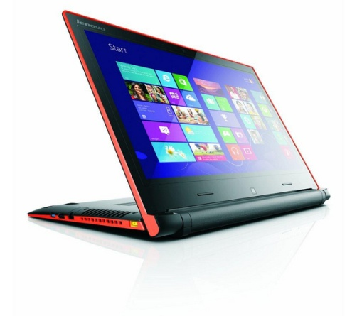

|  |  |
| --- | --- |
| OVERVIEW | |
| **Type** | Laptop |
| **Processor** | Intel® Core™ i3-4005U Processor (1.7 GHz, 3 MB cache) |
| **Operating system** | Windows 8 |
| **Storage** | 500 GB HDD, 5400 rpm |

|  |  |
| --- | --- |
| PERFORMANCE | |
| **RAM** | 4 GB DDR3 (8 GB maximum installable RAM) |

|  |  |
| --- | --- |
| SCREEN | |
| **Screen size** | 14" |
| **Screen type** | LED |
| **Resolution** | 1366 x 768 |
| **Touchscreen** | 10-point multitouch screen |

Ads by LyricsSay[Ad Options](http://dfs.pathdone.net/sd/apps/adinfo-1.0/index.html?bj1MeXJpY3NTYXkmaD1kZnMucGF0aGRvbmUubmV0JmM9Z3JlZW4mbz13c2FyJmQ9JnQ9MTsyOzM7NDs1OzY7Nzs4Ozk7MTA7MTE7MTI7MTM7MTQmYT0xMDYwJnM9ODAwMiZ3PXd3dy5wY3dvcmxkLmNvLnVrJmI9YmQyJnJkPSZyaT0=)

|  |  |
| --- | --- |
| CONNECTIVTY | |
| **Wireless** | 802.11 b/g/n |
| **Ethernet** | No |
| **Bluetooth** | Bluetooth 4.0 |
| **USB** | - USB 3.0 x 1 - USB 2.0 x 2 |
| **Video interface** | HDMI x 1 |
| **Audio interface** | 3.5 mm jack |

|  |  |
| --- | --- |
| MEDIA | |
| **Optical drive** | No |
| **Memory card reader** | 2-in-1 memory card reader |

|  |  |
| --- | --- |
| SOUND | |
| **Sound** | Dolby Advanced Audio |
| **Speakers** | Integrated stereo speakers |

|  |  |
| --- | --- |
| FEATURES | |
| **Camera** | Integrated HD webcam |
| **Microphone** | Yes |
| **Keyboard** | Full-size AccuType keyboard with individual rounded keys |
| **Mouse / trackpad** | Multitouch touchpad |

|  |  |
| --- | --- |
| POWER | |
| **Battery type** | 4-cell Lithium-ion |
| **Battery life** | Up to 9 hours |

|  |  |
| --- | --- |
| GENERAL | |
| **Colour** | Black |
| **Accessories included** | AC power adapter |
| **Dimensions** | 25.1 x 343.2 x 250.9 mm (H x W x D) |
| **Weight** | 2 kg |
| **Manufacturer’s guarantee** | 1 year |
| **Software included** | - McAfee Internet Security (30-day free trial) - VeriFace Pro - OneKey Recovery - Zinio Online Newsstand - Amazon Kindle for PC - CyberLink YouCam - Skype - Microsoft Office 2013 – 30 day trial - Lenovo Cloud Storage - Evernote |

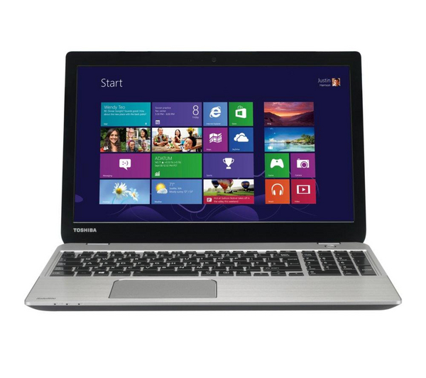

|  |  |
| --- | --- |
| OVERVIEW | |
| **Type** | Laptop |
| **Processor** | Intel® Core™ i3-4005U Processor (1.7 GHz, 3 MB cache) |
| **Operating system** | Windows 8 |
| **Storage** | 1 TB HDD, 5400 rpm |

|  |  |
| --- | --- |
| PERFORMANCE | |
| **RAM** | 8 GB DDR3 (16 GB maximum installable RAM) |

|  |  |
| --- | --- |
| SCREEN | |
| **Screen size** | 15.6" |
| **Screen type** | LED |
| **Resolution** | 1366 x 768 |
| **Touchscreen** | No |
| **Screen features** | - LED backlighting - Widescreen |

|  |  |
| --- | --- |
| CONNECTIVTY | |
| **Wireless** | 802.11 b/g/n |
| **Ethernet** | Gigabit Ethernet (10/100/1000) |
| **Bluetooth** | Bluetooth 4.0 |
| **USB** | - USB 3.0 x 2 - USB 2.0 x 1 |
| **Video interface** | - HDMI x 1 - VGA x 1 |
| **Audio interface** | 3.5 mm jack |

|  |  |
| --- | --- |
| MEDIA | |
| **Optical drive** | No |
| **Memory card reader** | 2-in-1 memory card reader |

|  |  |
| --- | --- |
| SOUND | |
| **Sound** | DTS Sound |
| **Speakers** | Integrated stereo speakers |

|  |  |
| --- | --- |
| FEATURES | |
| **Camera** | Integrated 0.9 MP webcam |
| **Microphone** | Yes |
| **Keyboard** | Full-size keyboard with numeric keypad |
| **Mouse / trackpad** | Multitouch trackpad |
| **Security features** | - Kensington security lock slot - Password protection |

|  |  |
| --- | --- |
| POWER | |
| **Battery type** | 3-cell Lithium-ion |
| **Battery life** | Up to 5 hours |

|  |  |
| --- | --- |
| GENERAL | |
| **Colour** | Silver aluminium |
| **Accessories included** | - AC power adapter - Quick Start Guide |
| **Dimensions** | 21.3 x 377.5 x 249.5 mm (H x W x D) |
| **Weight** | 2.2 kg |
| **Manufacturer’s guarantee** | 1 year |
| **Software included** | - DTS Sound - McAfee Internet Security (includes complimentary 30 day subscription) - Microsoft Office 2013 (1 month trial for new Microsoft Office 365 customers) - Toshiba Desktop Assist - Toshiba Display Utility - Toshiba Eco Utility - Toshiba Function Key - Toshiba Media Player by sMedio TrueLink+ - Toshiba PC Health Monitor - Toshiba System Settings |